**Serology Inference Simulations**

**Scenarios**

* A: constant FOI (endemic, constant)
* B: piecewise decreasing trend (endemic, monotonic decreasing)
* C: continuous increasing trend (endemic, monotonic increasing)
* D: 1 big outbreak (epidemic)
* E: 1 small outbreak (epidemic)
* F: 2 two outbreaks (epidemic)

**Sequential Model Selection process**

* 1) Select only the ones that converged (measured as R^ < 1.01)
* 2) then, select the ones with P value < 0.05 (Based on the method in your book), when compared to constant model
* 3a) If = one model left, choose that one
* 3b) If > one model left, choose the one with the highest *elpd* difference compared to the constant model
* 3c) If < one model left, choose the constant model

**Results:**

Model Inference OK, model selection OK



Model Inference OK, model selection NOT good



Model Inference is very wrong (sample size problem)

**A: constant FOI (endemic), small and aggregated sample size**

****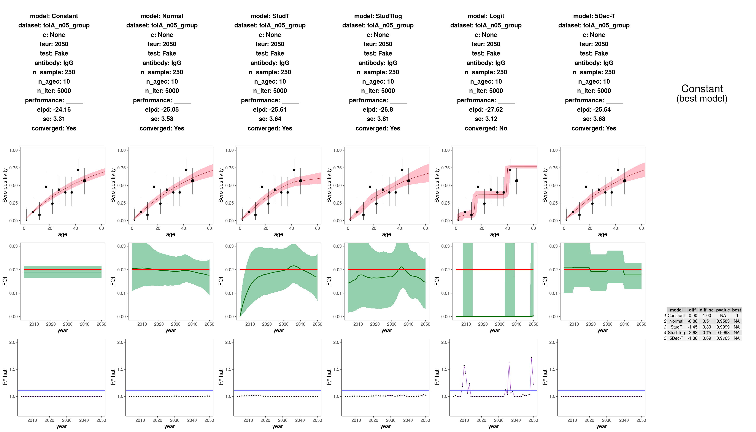

**A: constant FOI (endemic, constant), large and single age sample**

****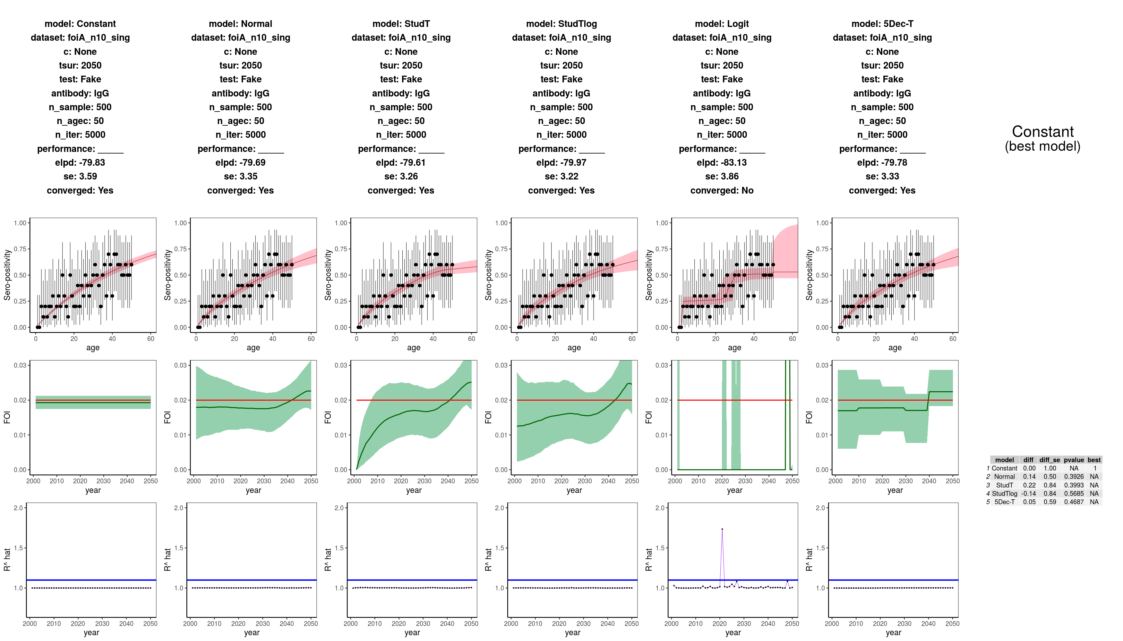

**B: piecewise decreasing trend (endemic, monotonic decreasing), small and grouped sample**

****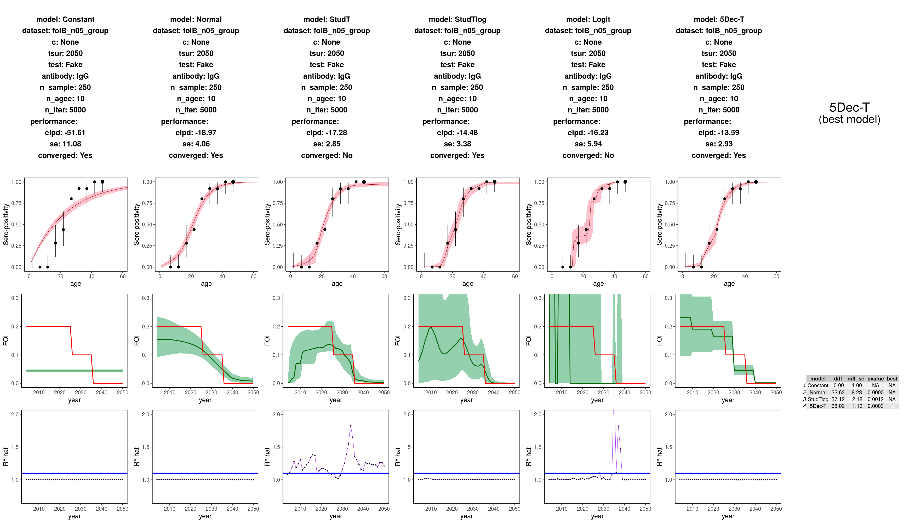

**B: piecewise decreasing trend (endemic, monotonic decreasing), large and grouped sample**

****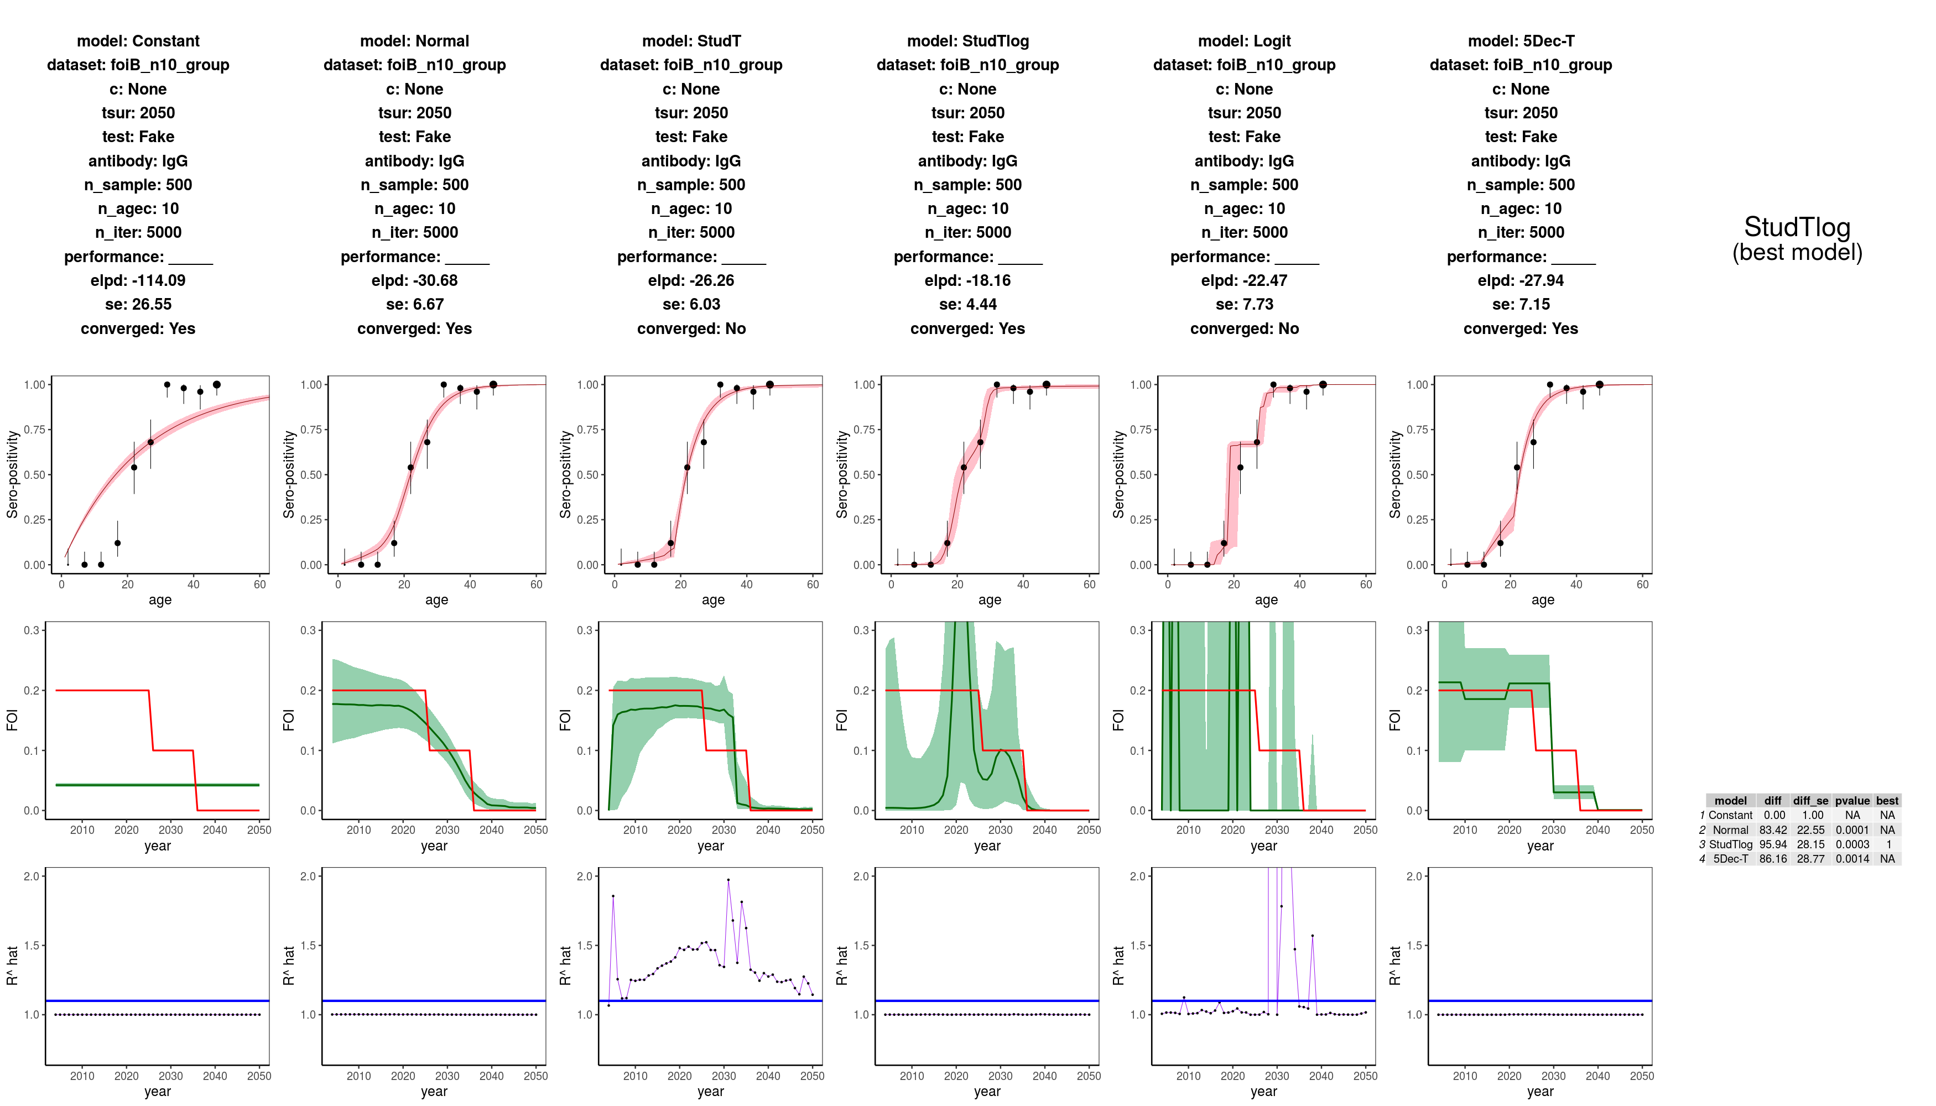

Here I would like either the normal or the decades to be selected. Either of those two are more parsimonious than the StudTLog model.

**C: continuous increasing trend (endemic, monotonic increasing). Small and single age sample**

****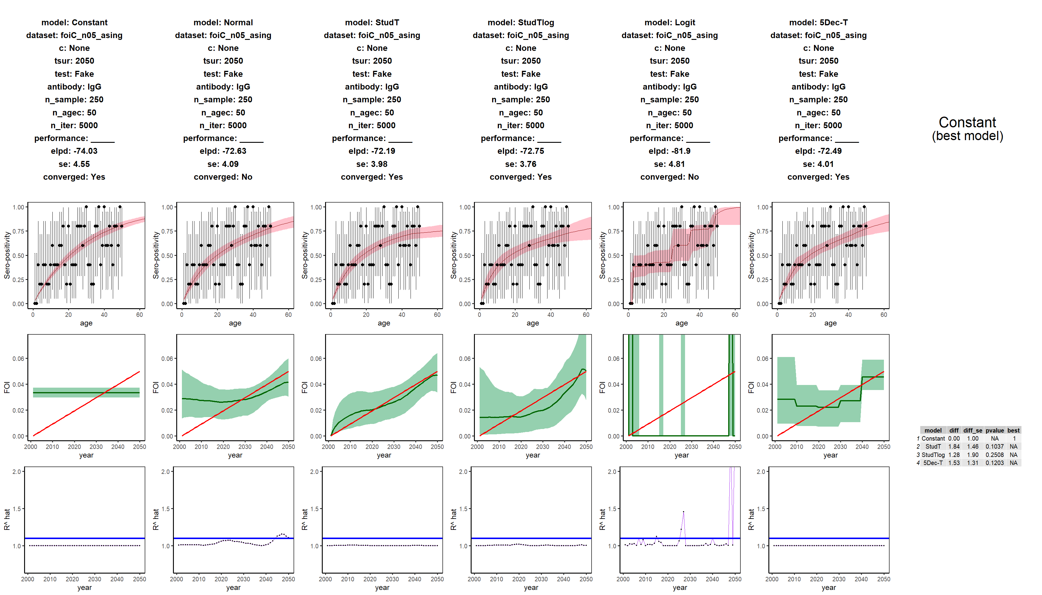

WRONG INFERENCE! Although all models converge, no model is significantly better than the constant one.

SAMPLE SIZE PROBLEM

**C: continuous increasing trend (endemic, monotonic increasing). Small and grouped sample**

****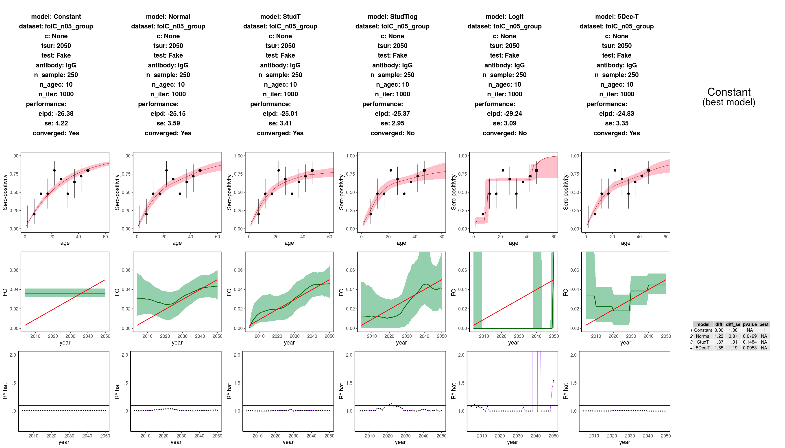

WRONG INFERENCE! Although all models converge, no model is significantly better than the constant one.

SAMPLE SIZE PROBLEM

**C: continuous increasing trend (endemic, monotonic increasing). Large and single age sample**

****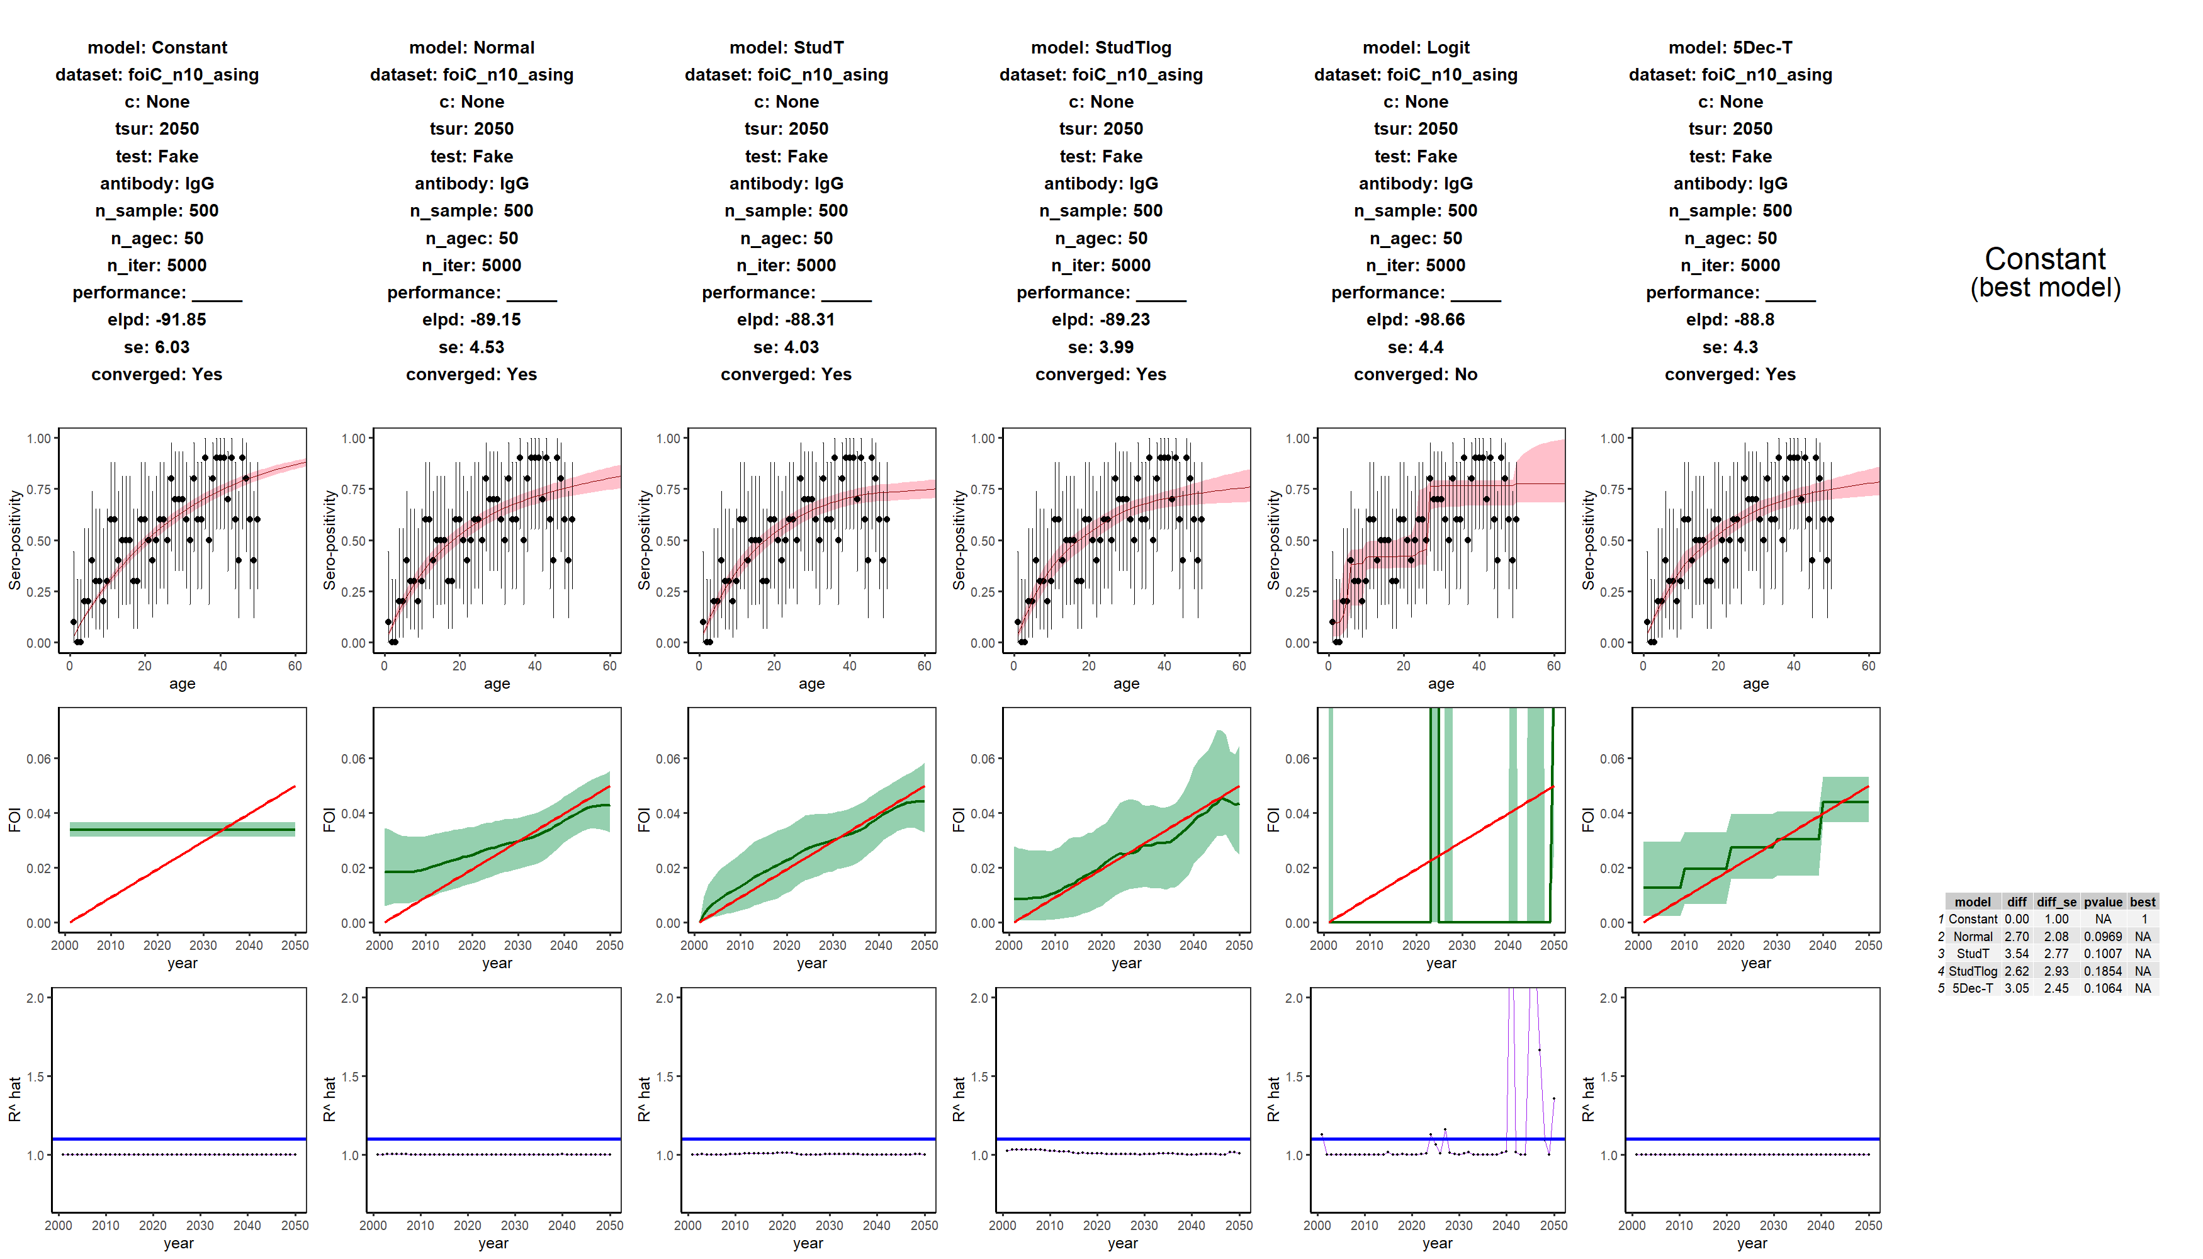

WRONG INFERENCE! Although all models converge, no model is significantly better than the constant one.

SAMPLE SIZE PROBLEM

**C: continuous increasing trend (endemic, monotonic increasing). VERY large and single age sample**

****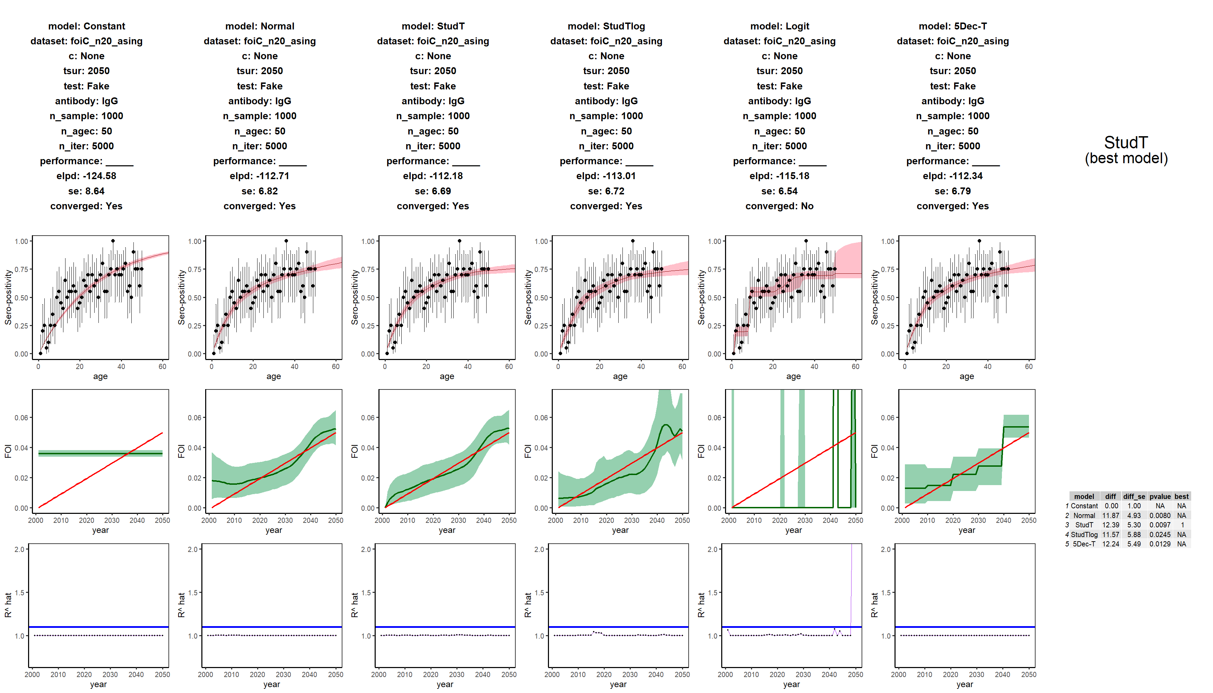

**C: continuous increasing trend (endemic, monotonic increasing). Large and grouped sample**

****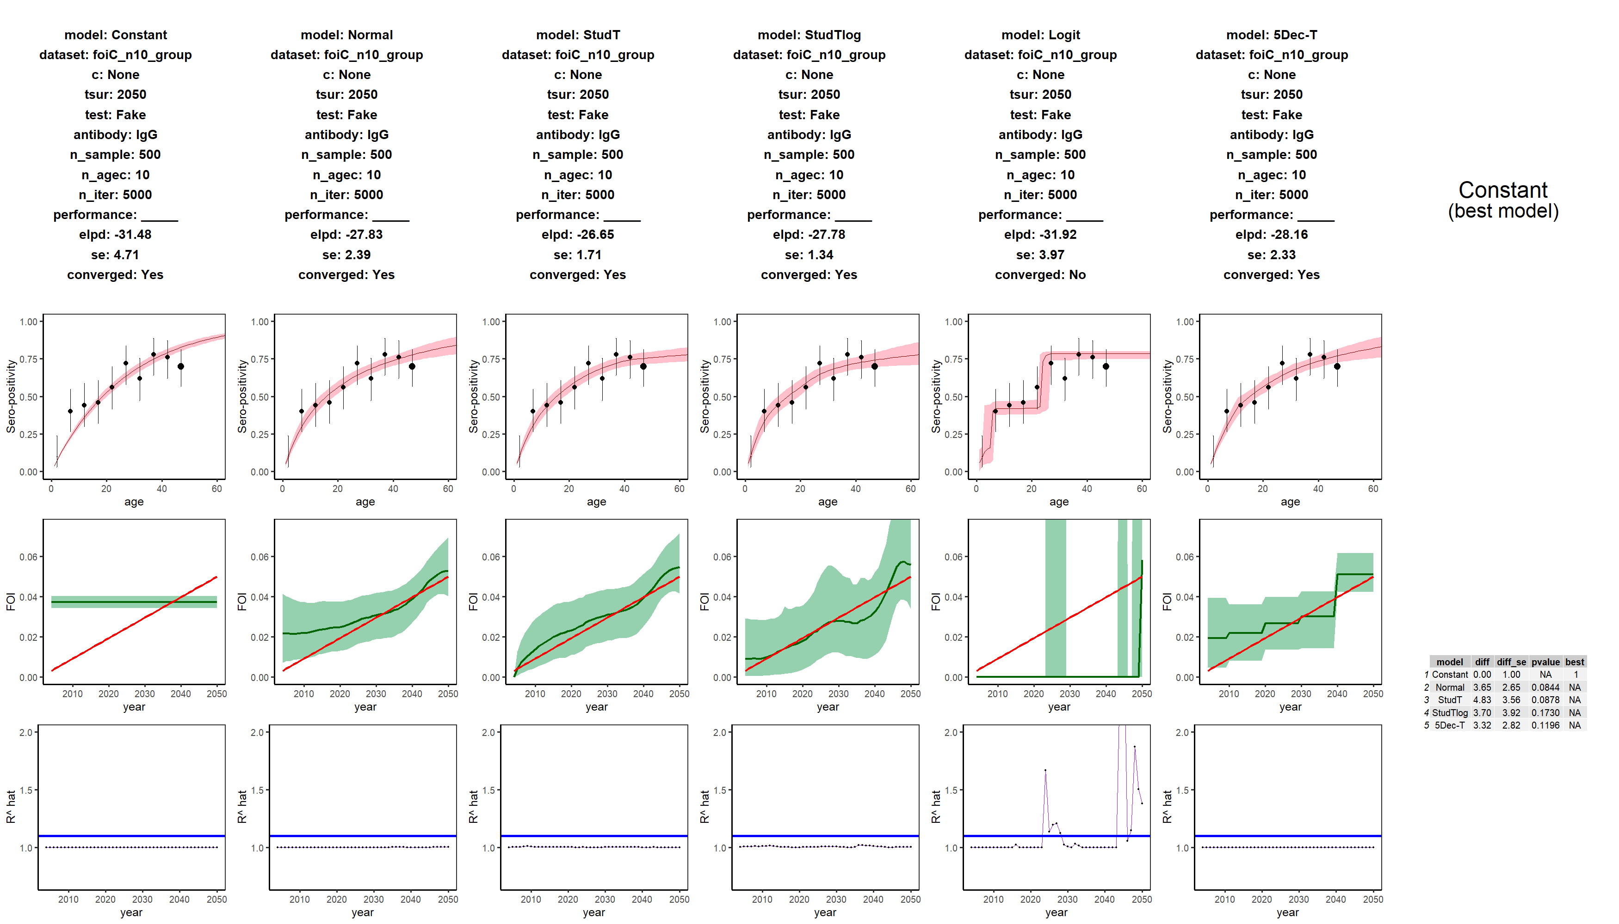

WRONG INFERENCE! Although all models converge and are better, no model is significantly better than the constant one (p value > 0.05)

SAMPLE SIZE PROBLEM

**D: large epidemic. Small and grouped sample**

****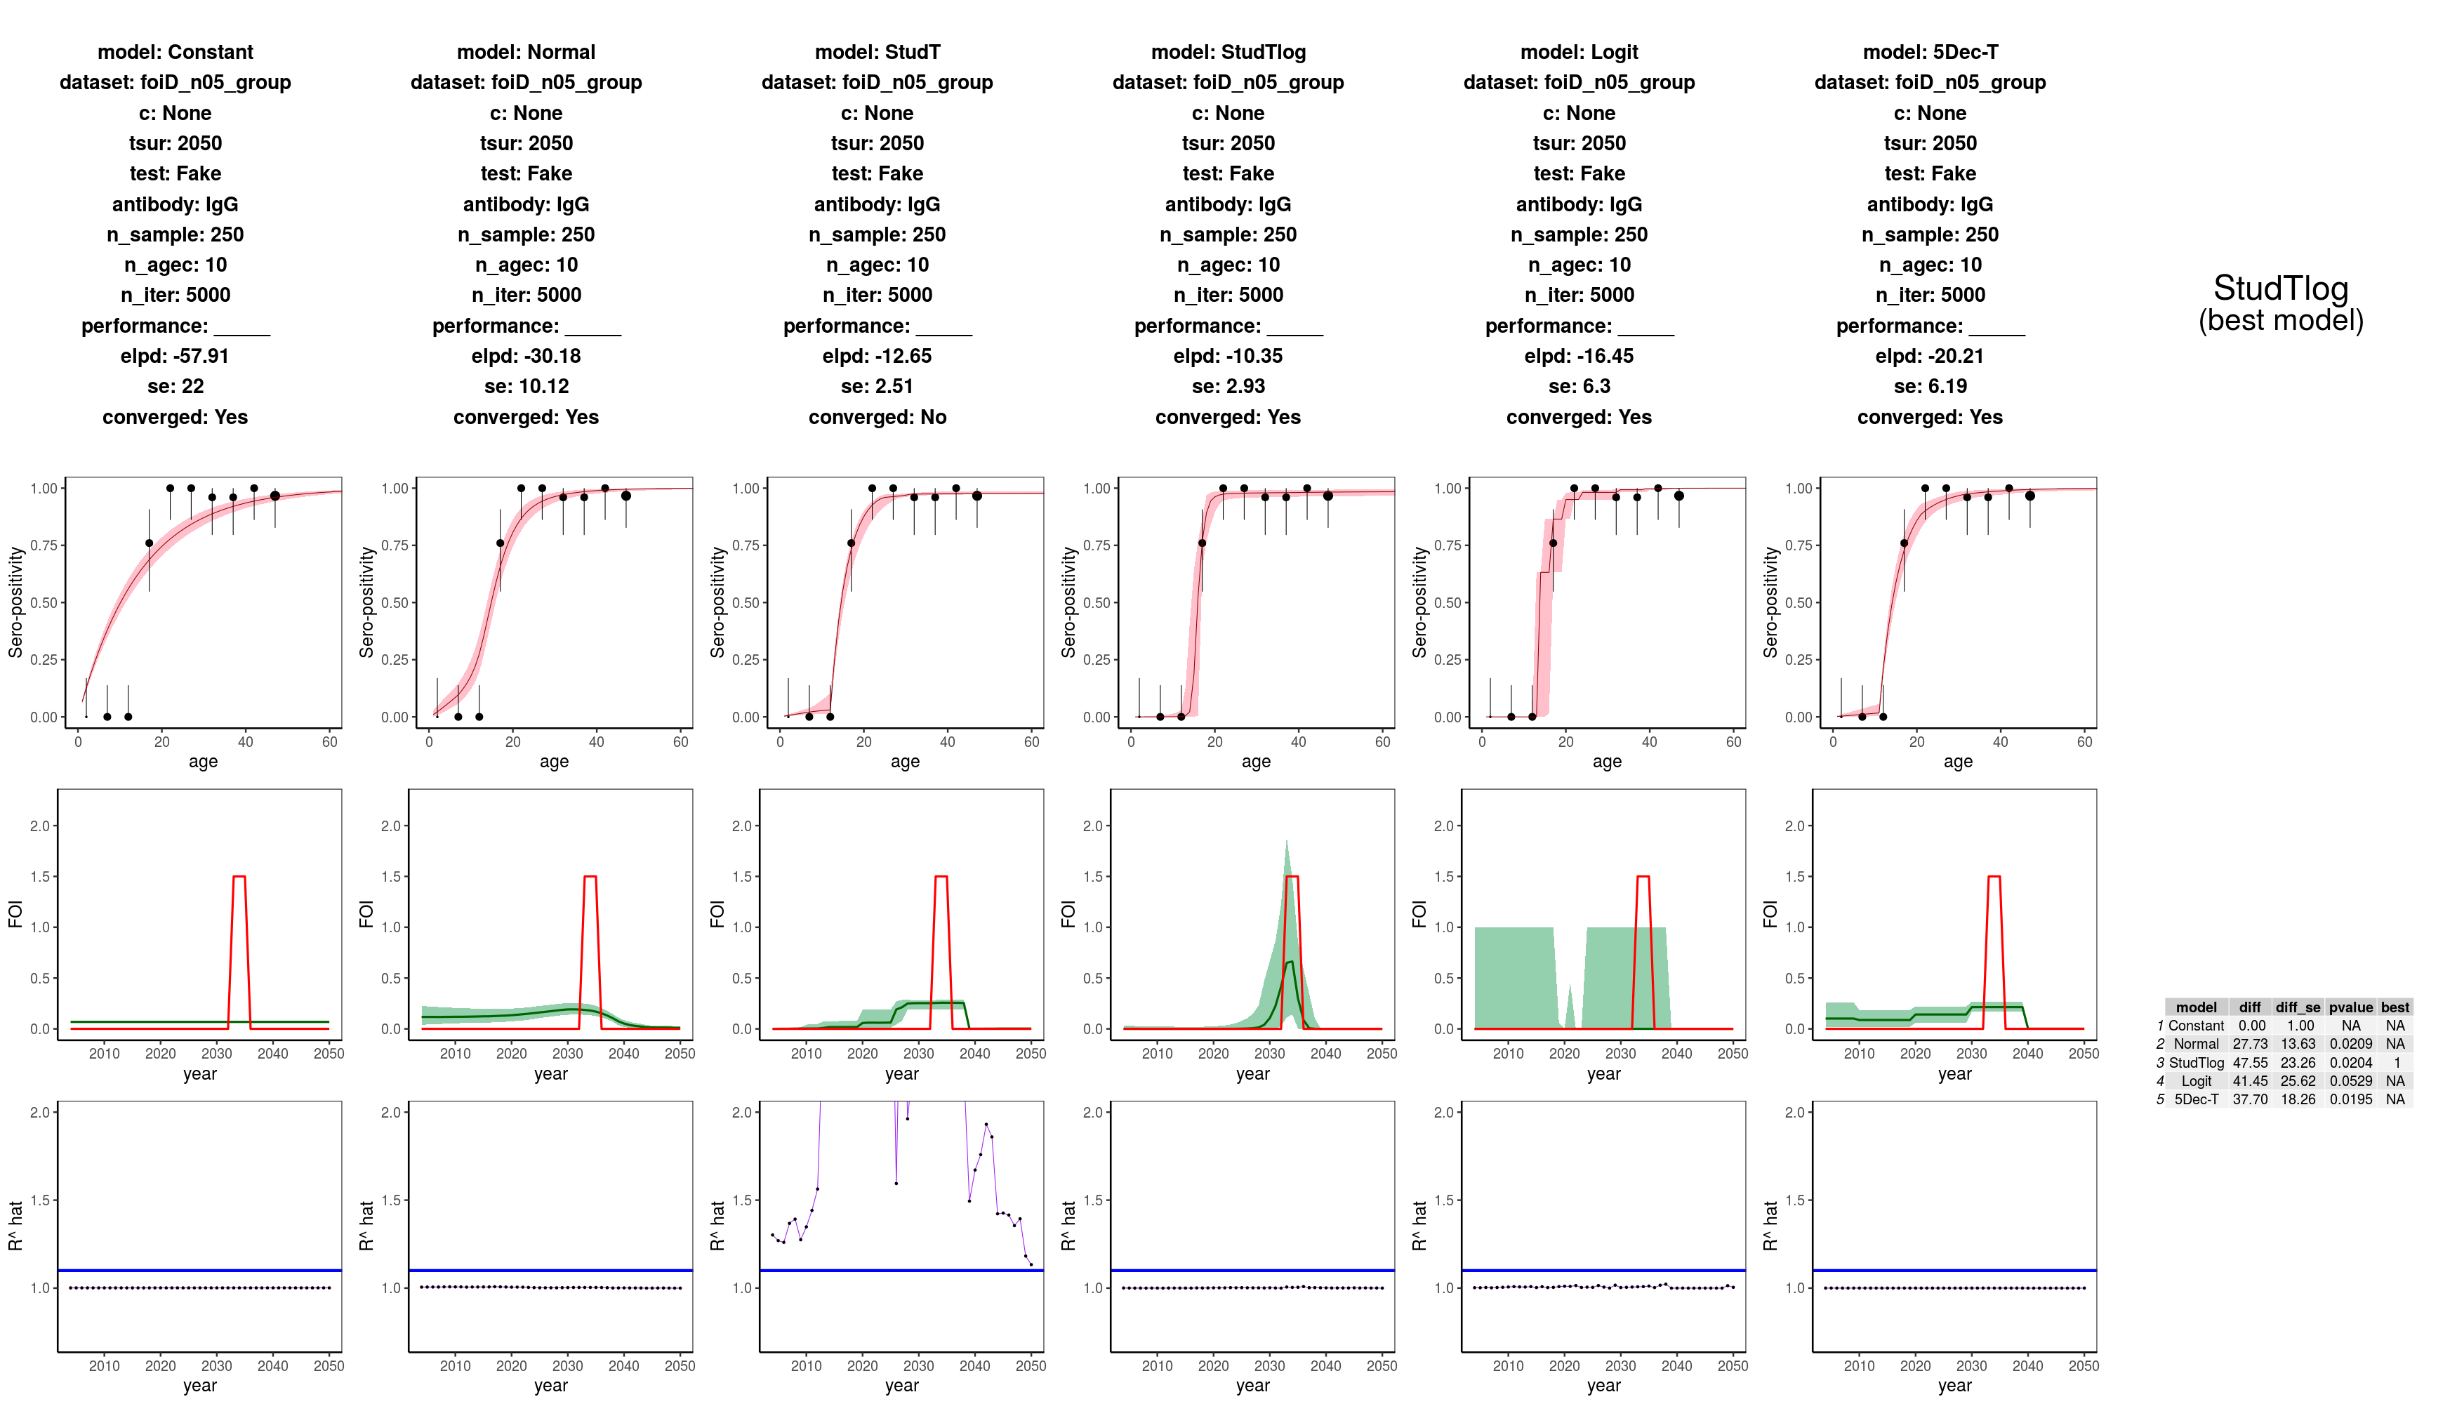

**D: large epidemic. Small and single age sample**

****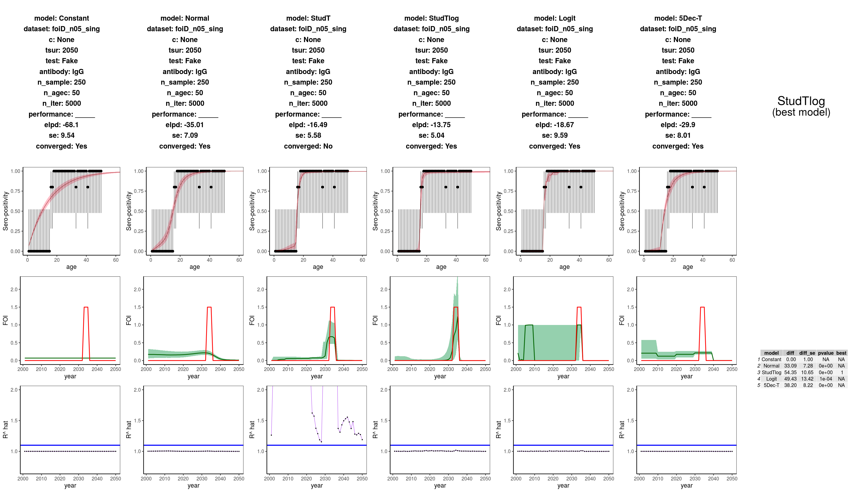

**E: small outbreak. Small and single age sample**

****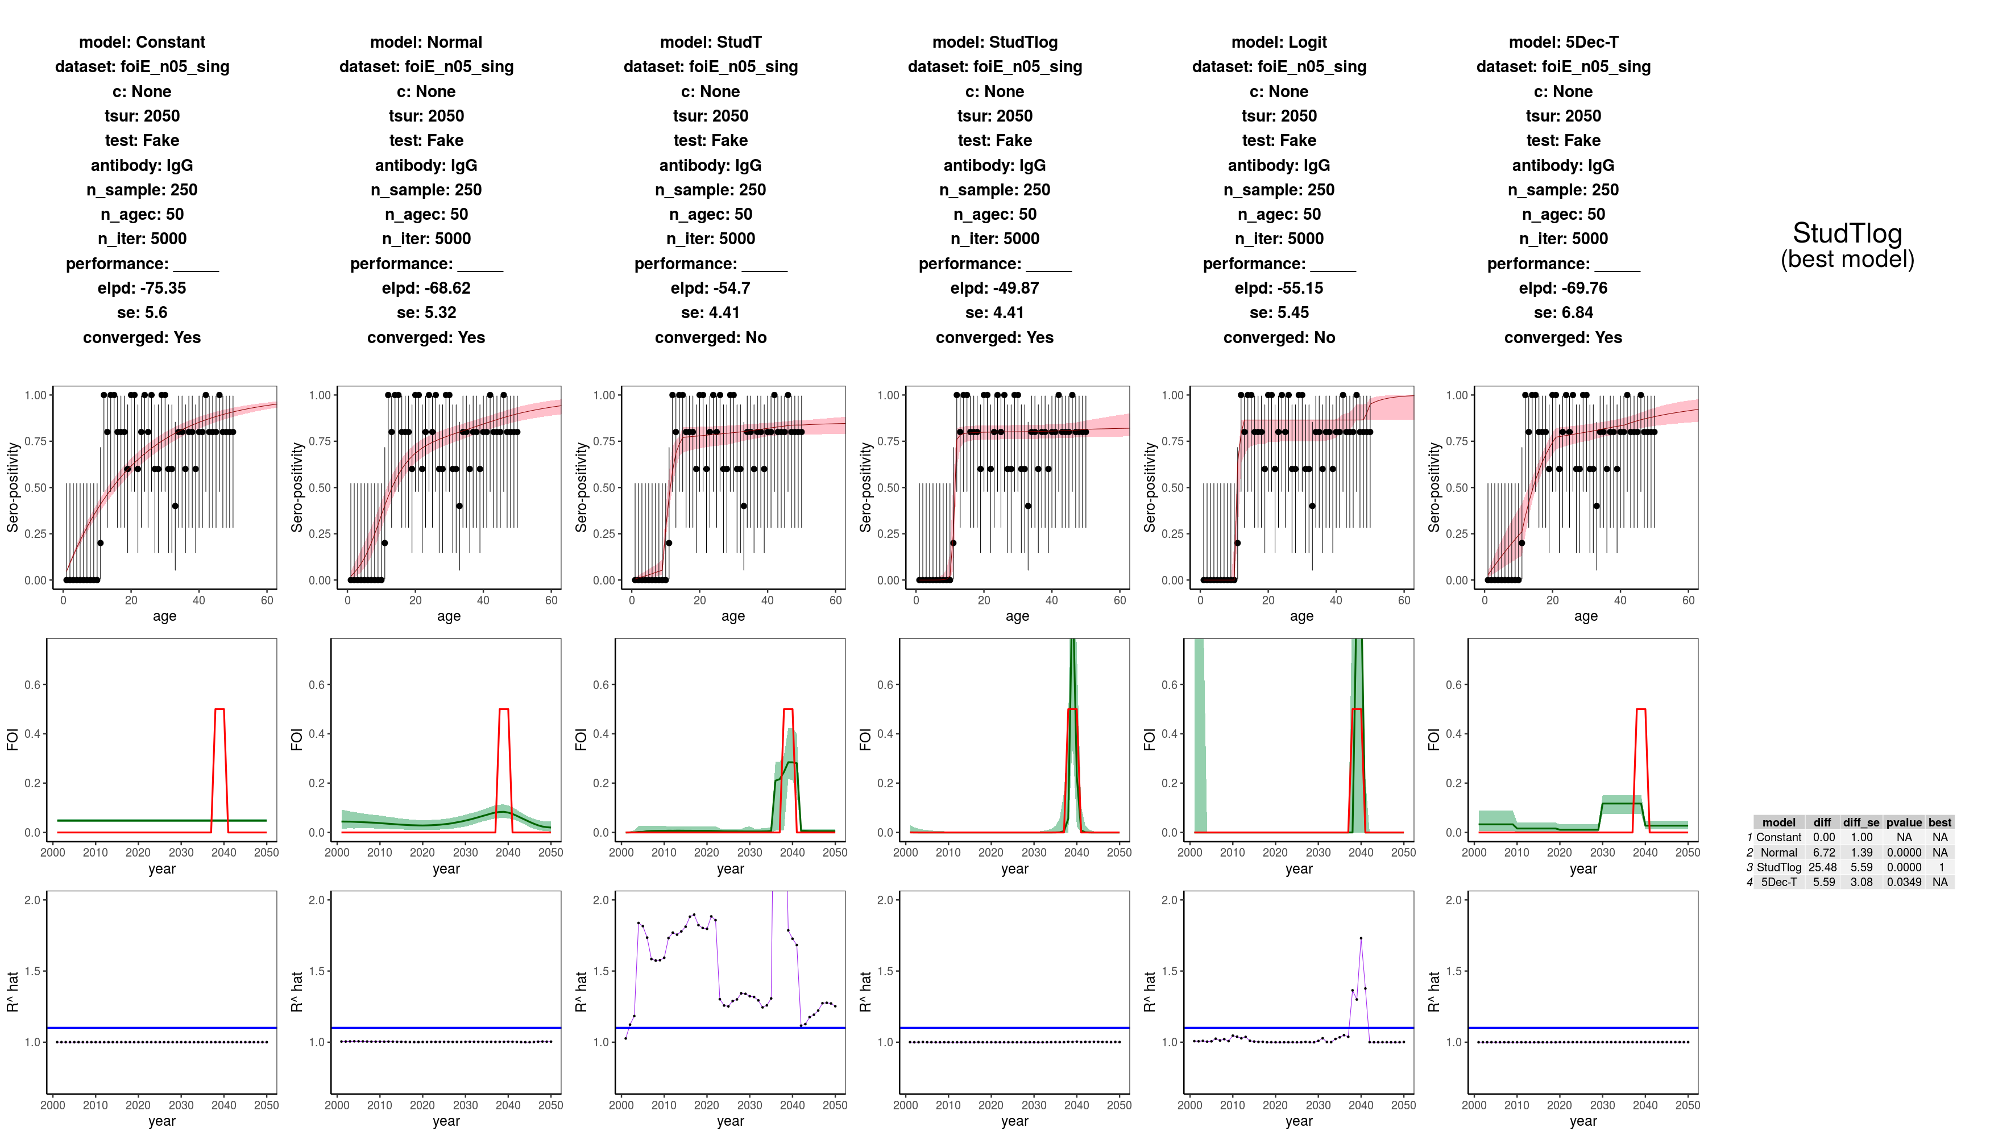

**E: small outbreak. Small and aggregated sample**

****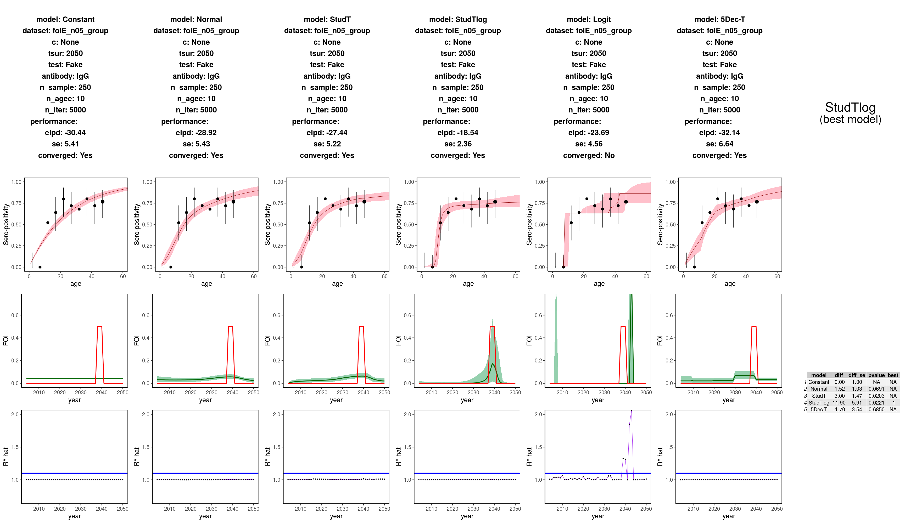

**E: small outbreak. Large and single age sample**

****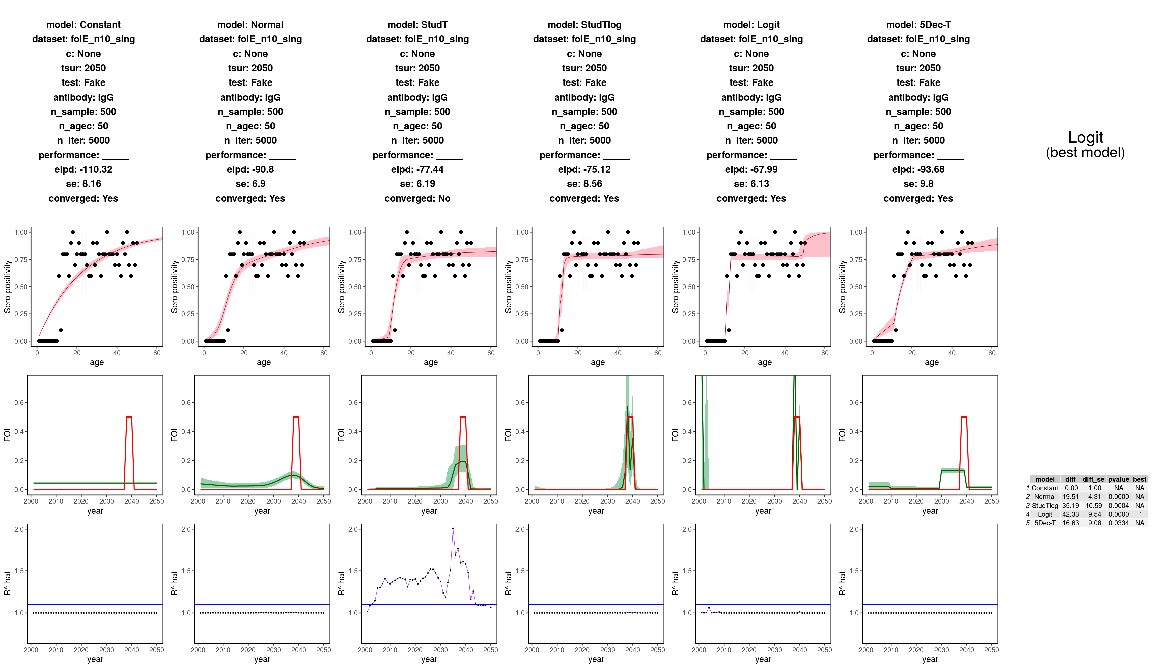

This suggests we should remove Logit model for good

**F: two outbreaks. Small and single age sample**

****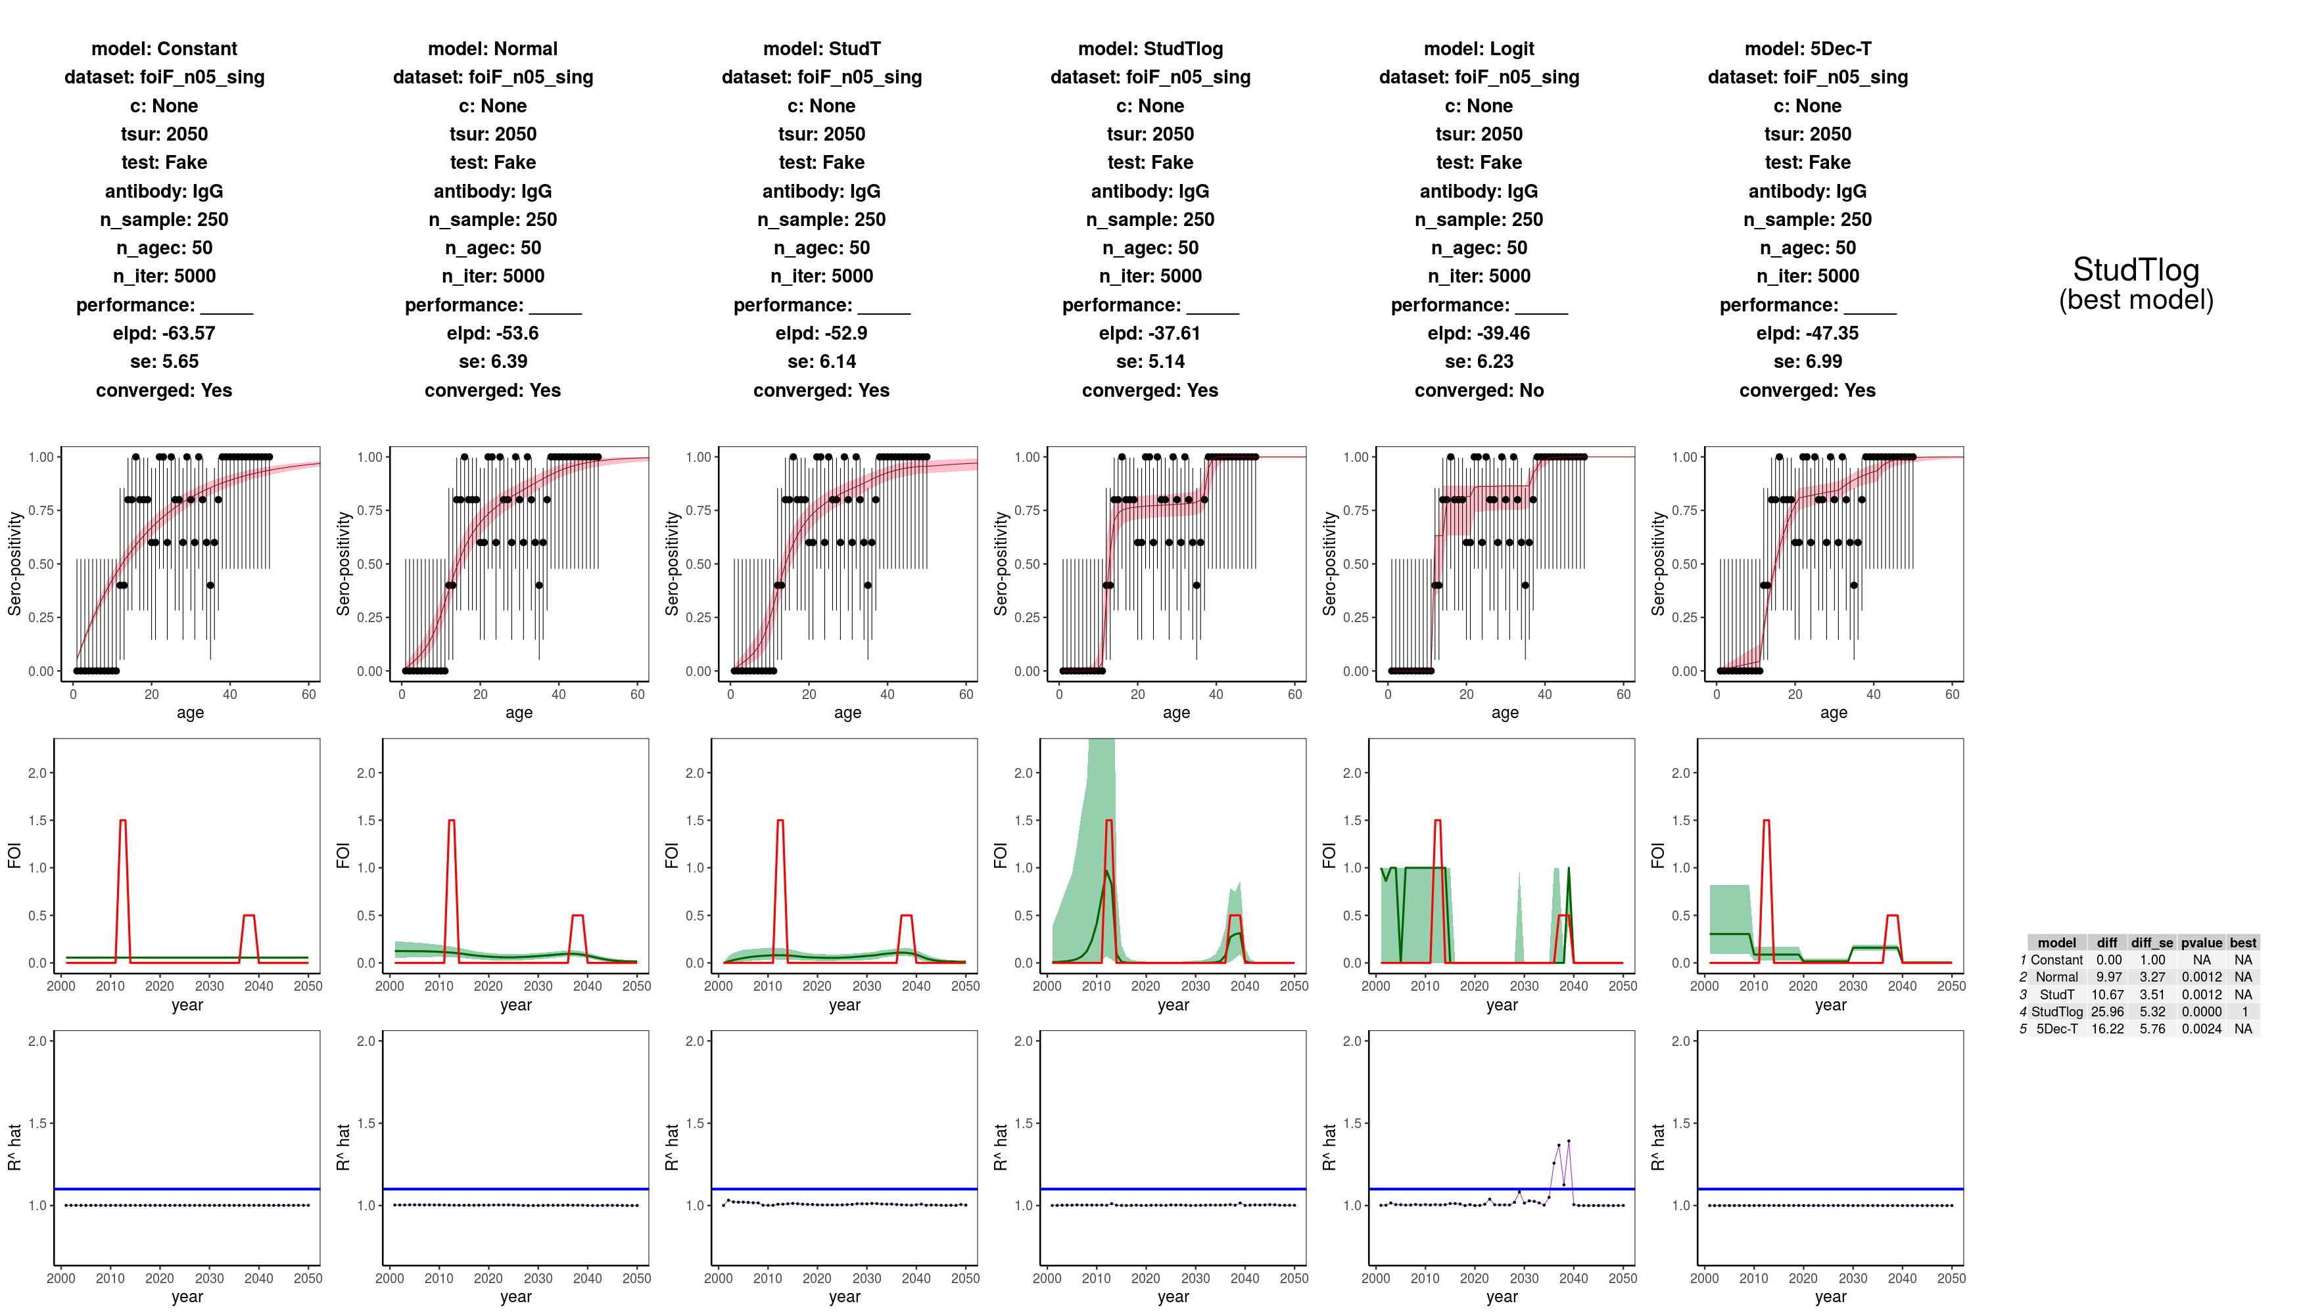

**F: two outbreaks. Small and aggregated sample**

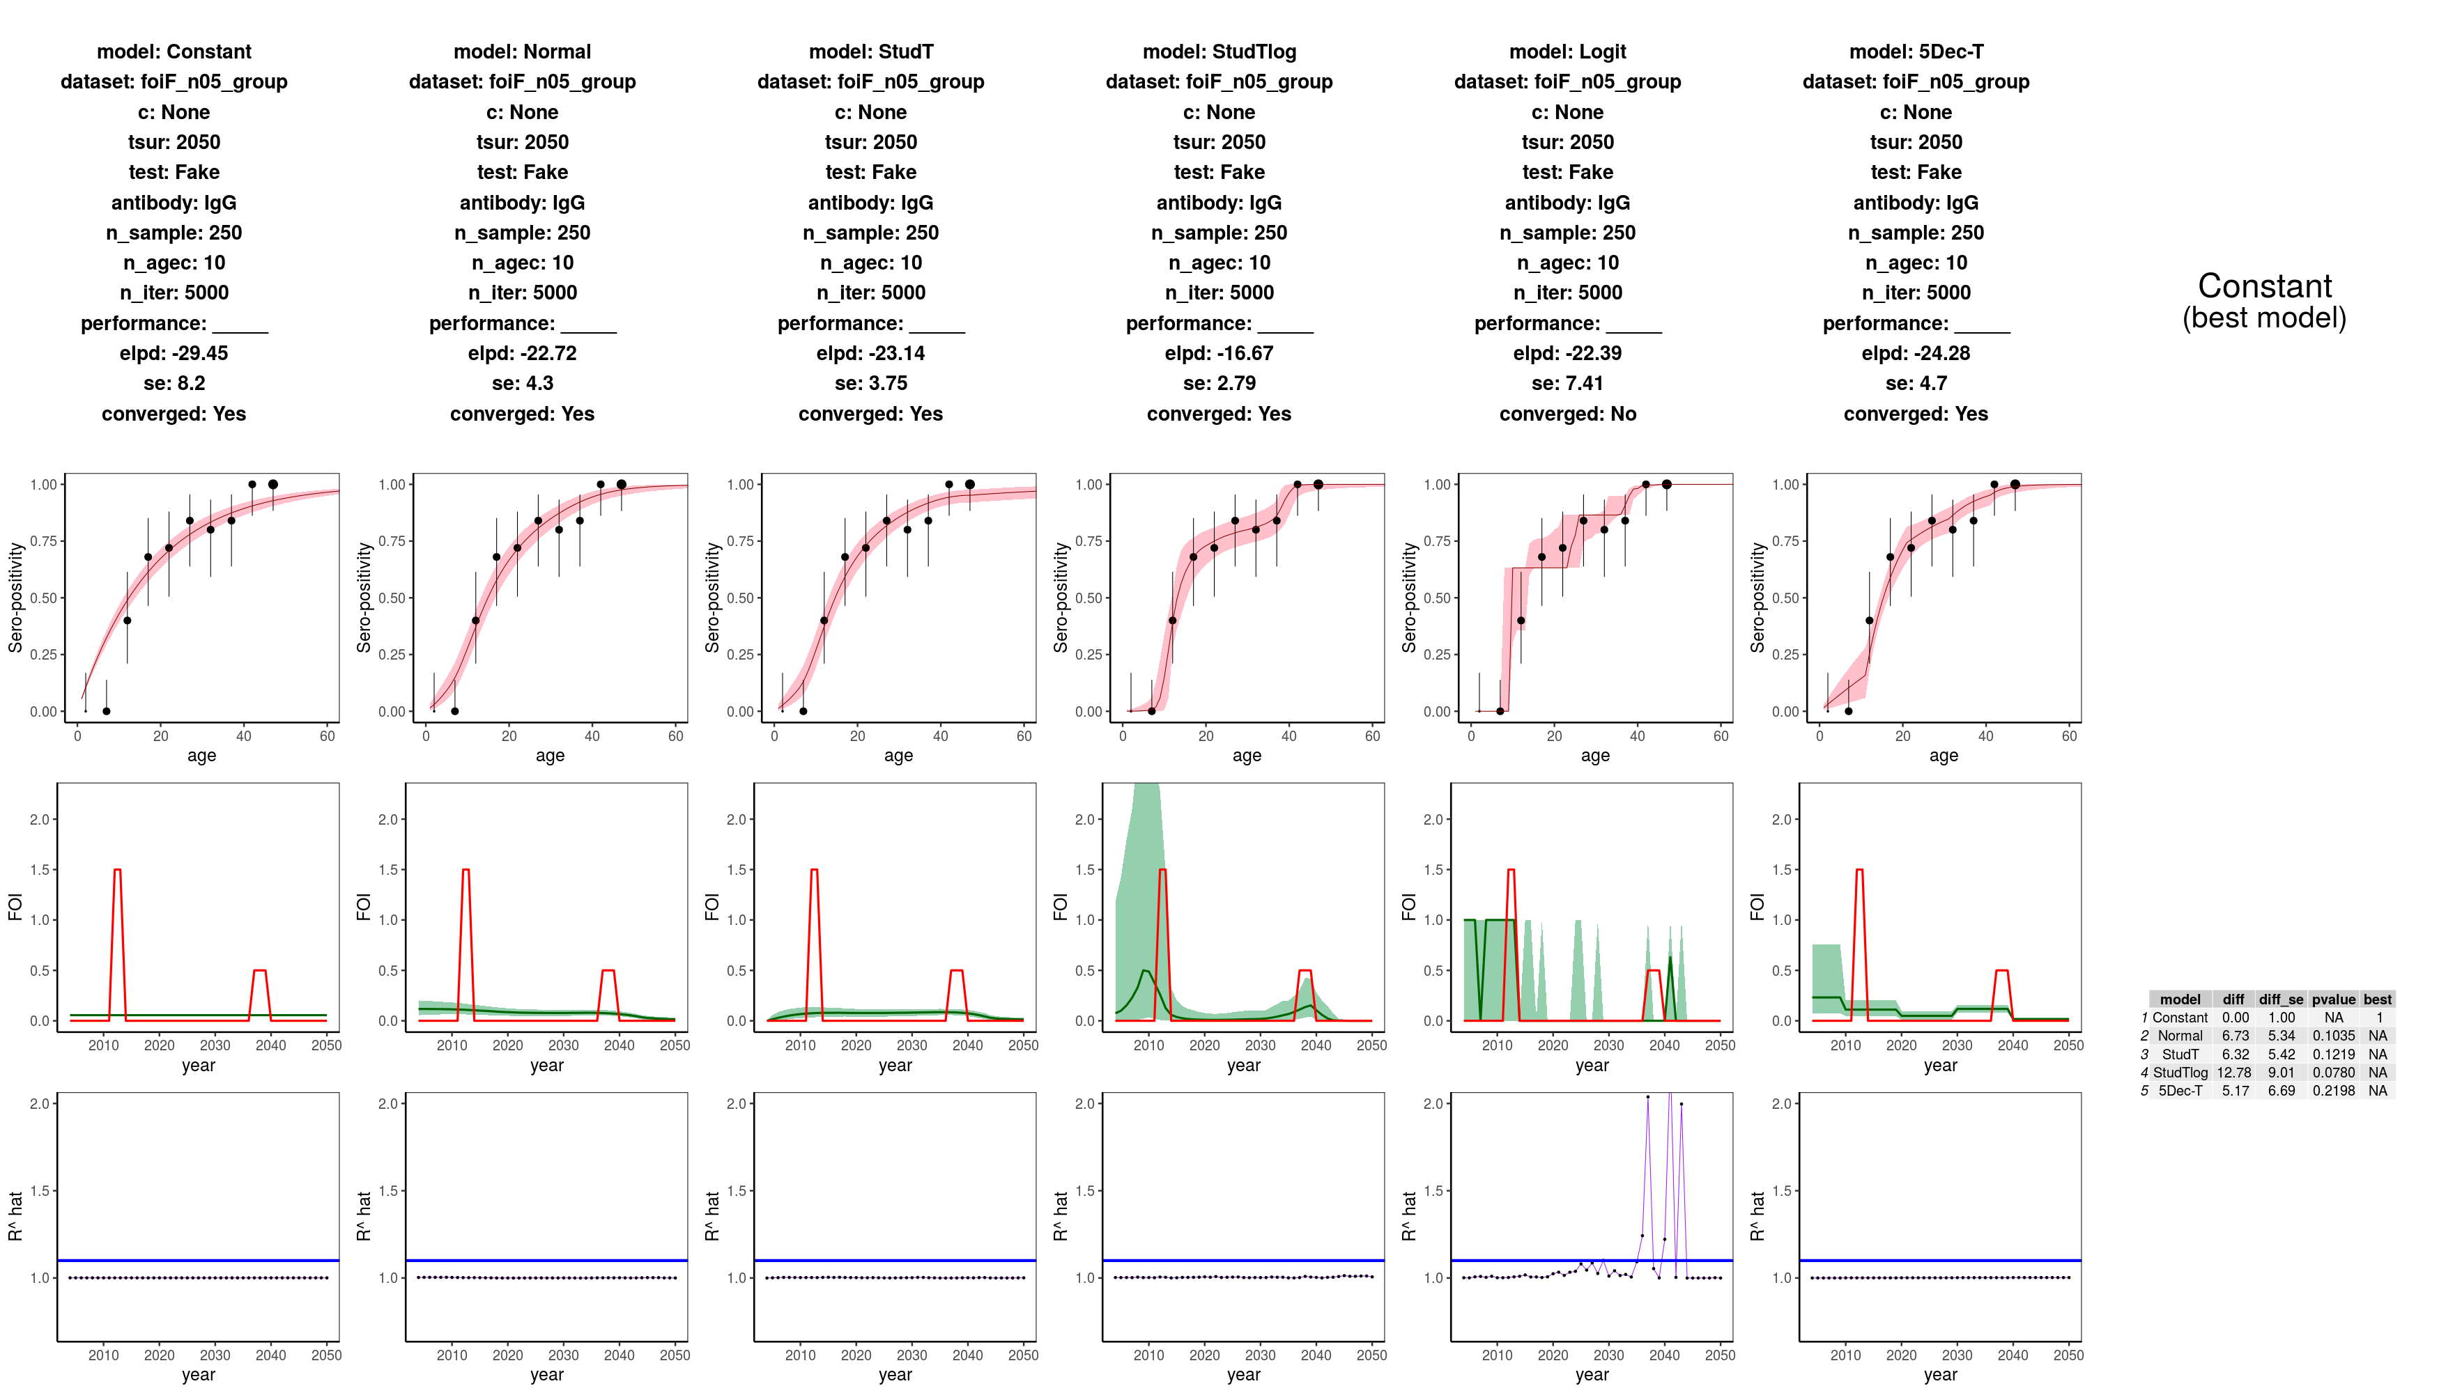

WRONG INFERENCE! Although all models converge, no model is significantly better than the constant one. (p value >0.05)

SAMPLE SIZE PROBLEM!

|  |  |  |  |  |
| --- | --- | --- | --- | --- |
| **Scenario** | | **Sample**  **size** | **Aggregation** | **Model performance** |
| **A** | Flat constant | Small | single | **Thumbs up sign** |
| Flat constant | small | grouped | **Thumbs up sign** |
| Flat constant | large | single | **Thumbs up sign** |
| Flat constant | large | grouped | **Thumbs up sign** |
| **B** | Monotonic decreasing | small | single | **High voltage** |
| Monotonic decreasing | small | grouped | **High voltage** |
| Monotonic decreasing | large | single | **High voltage** |
| Monotonic decreasing | large | grouped | **High voltage** |
| **C** | Monotonic increasing | small | single | **Danger** |
| Monotonic increasing | small | grouped | **Danger** |
| Monotonic increasing | large | single | **Thumbs up sign** |
| Monotonic increasing | large | grouped | **Thumbs up sign** |
| **D** | 1 big outbreak | small | single | **Thumbs up sign** |
| 1 big outbreak | small | grouped | **Thumbs up sign** |
| 1 big outbreak | large | single | **Thumbs up sign** |
| 1 big outbreak | large | grouped | **Thumbs up sign** |
| **E** | 1 small outbreak | small | single | **Thumbs up sign** |
| 1 small outbreak | small | grouped | **Thumbs up sign** |
| 1 small outbreak | large | single | **Thumbs up sign** |
| 1 small outbreak | large | grouped | **Thumbs up sign** |
| **F** | 2 outbreaks | small | single | **Thumbs up sign** |
| 2 outbreaks | small | grouped | **Danger** |
| 2 outbreaks | large | single | **Thumbs up sign** |
| 2 outbreaks | large | grouped | **Thumbs up sign** |